HEX Color Model

📘 Definition
# Source: AI Source: Provided by: [Data Path: Persons Table -> ID Column: 1, Name_En Column: Motasem Essam] -> From: [ChatGPT] on [5/2/2026]
The HEX color model (Hexadecimal color model) is a way to represent colors using a 6-digit code made of numbers and letters. It is mainly used in web design (HTML and CSS) to define colors.

🎨 How HEX colors work
# Source: AI Source: Provided by: [Data Path: Persons Table -> ID Column: 1, Name_En Column: Motasem Essam] -> From: [ChatGPT] on [5/2/2026]
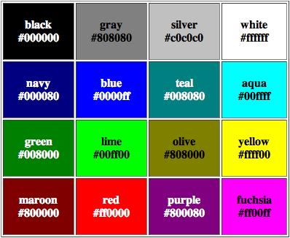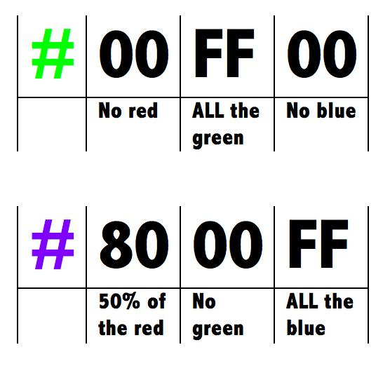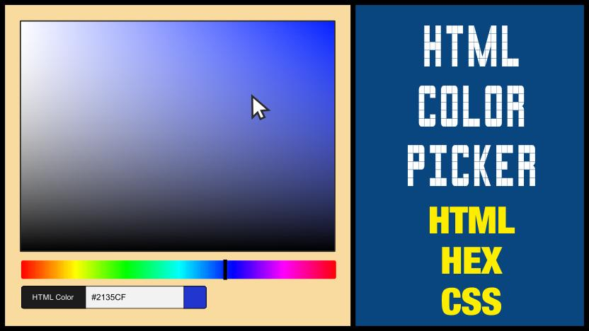
A HEX color code looks like this:
#RRGGBB
Where:
- RR = Red value
- GG = Green value
- BB = Blue value
Each pair is written in hexadecimal (0–9, A–F):
- 00 = no color
- FF = full intensity

🧠 HEX Color Examples
# Source: AI Source: Provided by: [Data Path: Persons Table -> ID Column: 1, Name_En Column: Motasem Essam] -> From: [ChatGPT] on [5/2/2026]
🎯 Basic colors
- Black → #000000
- White → #FFFFFF
- Red → #FF0000
- Green → #00FF00
- Blue → #0000FF

🎨 Mixed colors Examples
# Source: AI Source: Provided by: [Data Path: Persons Table -> ID Column: 1, Name_En Column: Motasem Essam] -> From: [ChatGPT] on [5/2/2026]
- Yellow (Red + Green) → #FFFF00
- Cyan (Green + Blue) → #00FFFF
- Magenta (Red + Blue) → #FF00FF
- Orange → #FFA500
- Purple → #800080
- Pink → #FFC0CB

🧑‍💻 Where HEX is used
# Source: AI Source: Provided by: [Data Path: Persons Table -> ID Column: 1, Name_En Column: Motasem Essam] -> From: [ChatGPT] on [5/2/2026]
- 🌐 Web design (HTML & CSS)
- 🎨 Graphic design tools
- 📱 App UI design
- 🖥️ Website themes and styling
Example in CSS:
background-color: #FF5733;

⚙️ How HEX relates to RGB
# Source: AI Source: Provided by: [Data Path: Persons Table -> ID Column: 1, Name_En Column: Motasem Essam] -> From: [ChatGPT] on [5/2/2026]
HEX is just another way to write RGB values:
- #FF0000 = RGB(255, 0, 0)
- #00FF00 = RGB(0, 255, 0)
- #0000FF = RGB(0, 0, 255)

🚀 In short:
# Source: AI Source: Provided by: [Data Path: Persons Table -> ID Column: 1, Name_En Column: Motasem Essam] -> From: [ChatGPT] on [5/2/2026]
HEX color model = a 6-digit code system used to represent RGB colors in web design and digital graphics.

